标题：Network firewall Security 4 Ethernet pfsense firewall PC

关键词：Network firewall Security,pfsense firewall PC,4 Ethernet PC

ZC-H78-H3104L Mini PC With 4 Gigabit Ethernet Ports Intel H310 Chipset LGA1151 Socket Supports 8th,9th

Generation Processor i7/i5/i3/Celeron/Pentium,With 1*DP,1*HDMI,4*Ethernet,4*USB 3.0,2*USB 2.0

2*COM Optional,WIFI/4G Module Optional

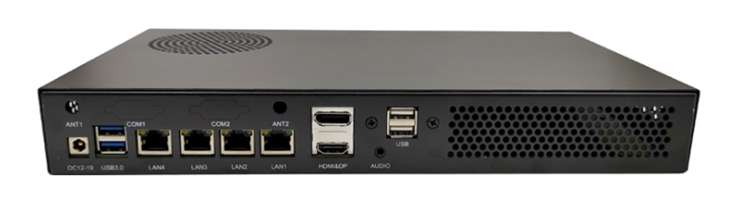

**Main Features:**

1.) Intel H310 Chipset,LGA1151 Core i7/i5/i3/Celeron/Pentium

2.) 4 Gigabit Intel I211 Ethernet Card

3.) 4 USB 3.0 +2*USB 2.0 Ports,2 COM Ports optional

4.) Rich Storage,1*3.5inch(or 2*2.5inch) +1*mSATA

5.) 2*SO-DIMM DDR4 Slot,Support Max 32GB

6.) 1*M.2 2230 Support WIFI/4G/3G Module.

7.) With DIN Rail Mount,easy to mount

8.) Wide used in pfsense firewall,network server,firewall appliance,firewall vpn,network router

**ZC-H78-3104L 4 Gigabit Ethernet Mini PC**

|  |  |
| --- | --- |
| Processor | Intel LGA1151 Socket  Supports Intel 8th,9th Intel CPU  Core i7/i5/i3/Celeron/Pentium |
| Chipset | Intel H310 |
| RAM | 2*SO-DIMM DDR4 |
| Graphics Card | Processor Integrated Graphics Card |
| Storage | 1*3.5inch(or 2*2.5inch),1*Mini SATA |
| Expansion Slot | 1*M.2 2230,Supports WIFI/3G/4G Module  1*PCI-E 4X |
| Display Port | 1*DP,1*HDMI |
| Network Card | 4*Intel I211 Ethernet Card,Gigabit |
| I/O Ports | 4*USB 3.0  2*USB 2.0  1*DP  1*HDMI  2*RS232  1*DC Port  4*RJ45 Ports  1*Power Button  1*3.5mm Audio(SPK+MIC) |
| Power Adapter | 19V |
| Dimension | 320x174x44mm |

